**ESD Protection**

Sources of ESD:

ESD models:

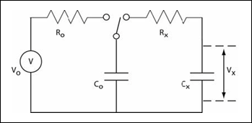

Worst case for automotive (ISO xxxxxx) with a contact discharge is Co= 330pf, Rx=330 Ohms

Typical input circuit:

Input capacitor:

Q=CV   
With Co = 330pF, VO=8kV, Q = 2.64uC

During a discharge the switch Co and Cx are connected in parallel with Rx limiting the current surge but not having any significant effect on the voltages.

With Co = 330pF and Cx = 10nF then the total capacitance = 10.33nF

To calculate the final voltage across Cx:

Vx = Q/C  
 V=2.64uC/10.33nF = 256V

A typical MLCC has a dielectric withstand voltage of 2.5 times its working voltage so in this case we require a 200V capacitor, for a 500V withstand voltage. A typical example of a suitable automotive component is a Kemet C0805F103K2RACTU

Note: An ESD capacitor on input to the ECU is usually followed by a series resistor, this resistor must be capable of tolerating the resultant ESD voltage.  
For example a TEC 1206 size CRGCQ series has a working voltage of 200V, and a dielectric withstand voltage of 500V.

Working backwards from our 500V limitation then the maximum ESD pulse that can be calculated as:

Q = 500V * 10.33nF = 5.165uC  
 Vmax = V = Q/C = 5.165uC/330pF  
 Vmax = 15.651kV

In a real case some current will flow into the rest of the circuit, ----- impedance of ESD cap?? Series resistor with clamp diode almost = 0V.

PCB Layout

During the ESD event a large current will travel through the ESD capacitor, the PCB must be well designed. What we don’t want to happen is for this current to travel across the PCB where stray inductances combined with the fast di/dt can cause large and potentially damaging voltages.

A good, very low impedance connection to 0V is essential, typical example below:

Insert pic here.

A very poor example is shown here:

Speeduino v4.3 pic